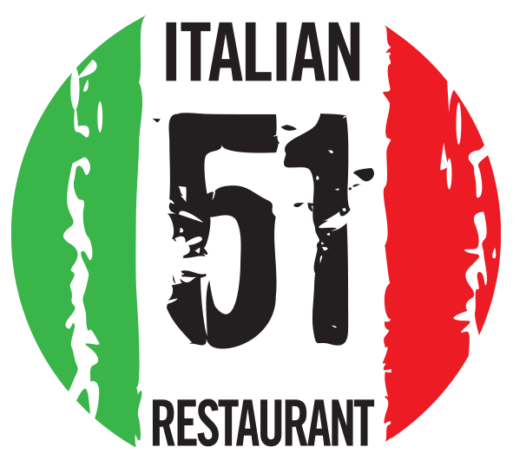 Christmas Day Menu @ 51 ITALIAN Liverpool
Contact Name: |  |  |  |  |  |  | Email:
Telephone: |  |  |  |  |  |  | * Special Request:
 | Name | Scallops | Prawn  Cocktail | Soup | Paté | Burrata |  |  | Turkey | Fillet | Lamb | Lobster  Ravioli | Parmigiana |  | Tiramisu |  |  | Cheesecake |  | Zuccotto |  |  | Brownie | Cheese | Ice  Cream | DIETARY REQUESTS

